**Part 1 - Basics**

* Init

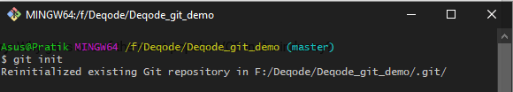

* Config





* Clone

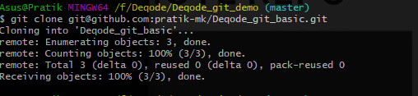

* Pull

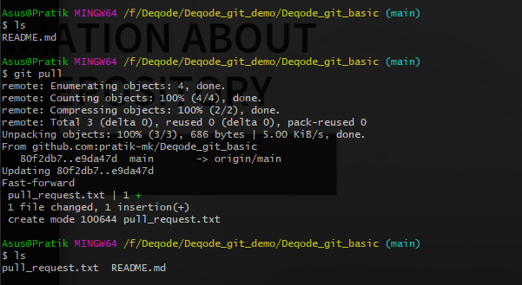

* Push

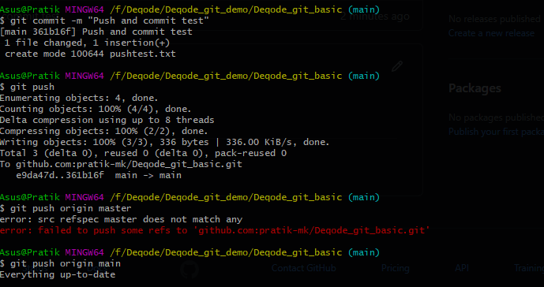

* **Sample Query:** Why git is one of the most popular VCS in the industry?  
  open source, decentralized

Part 2 - Commit Lifecycle

* Add  
  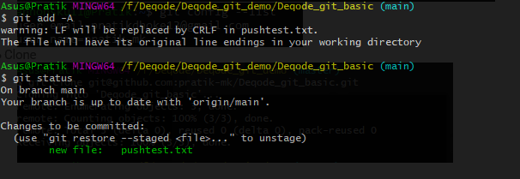
* Commit  
  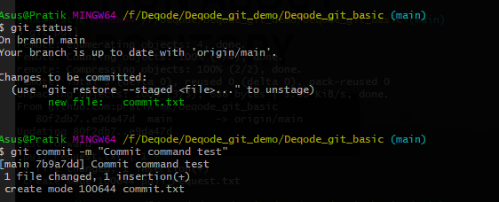
* Reset  
  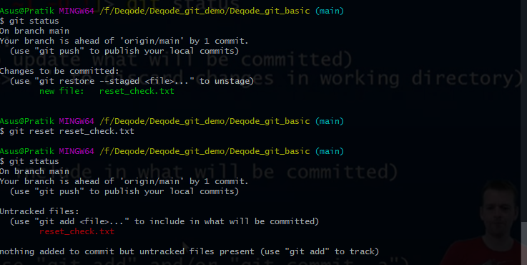
* Rm  
  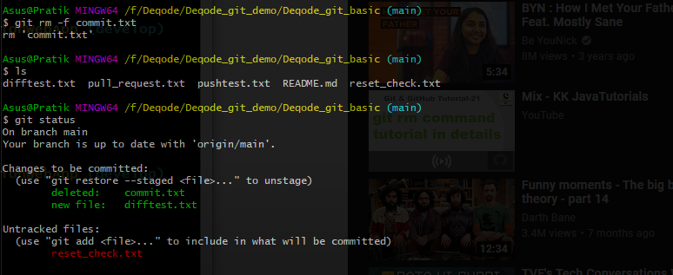
* Amend  
  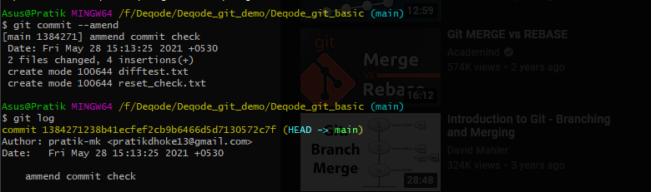
* **Sample Query:** What is Sha Hash?  
  **Git uses SHA**-**1**-generated **hashes** to identify revisions and protect code against corruption

Part 3 - More than Basics

* Diff  
  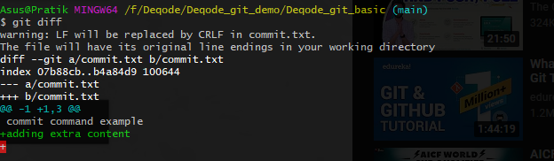
* log  
  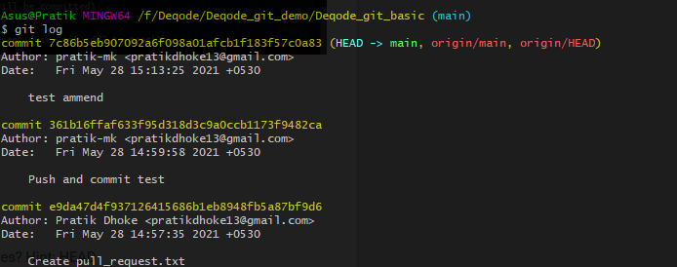
* stash  
  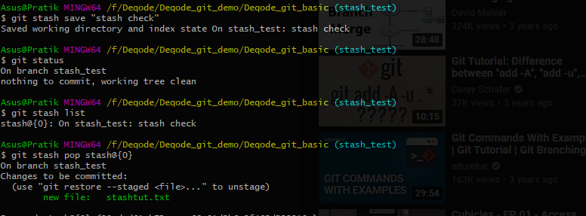
* revert  
  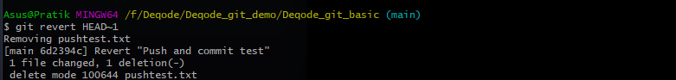
* **Sample Query:** How git calculates differences? Hint: HEAD  
   it runs two different **internal** variations on **git diff** : one to compare HEAD to the index/staging-area, and one to compare the staging-area to the **work**-tree.